**Manual Test Plan**

**Part I: Add jQuery to Your Portfolio**

Go to Projects-> Jquery Test and click details



Click on the Move block and see if the block moves



If the block moves to the center, then it is working Jquery is implemented working correctly

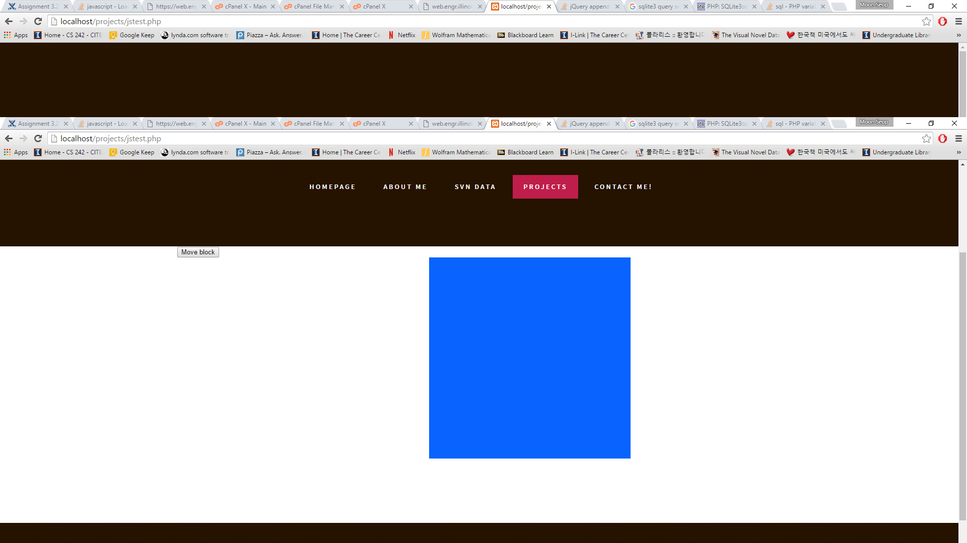

**Part II: Post Comments Asynchronously**

Go to projects->Chess->comments

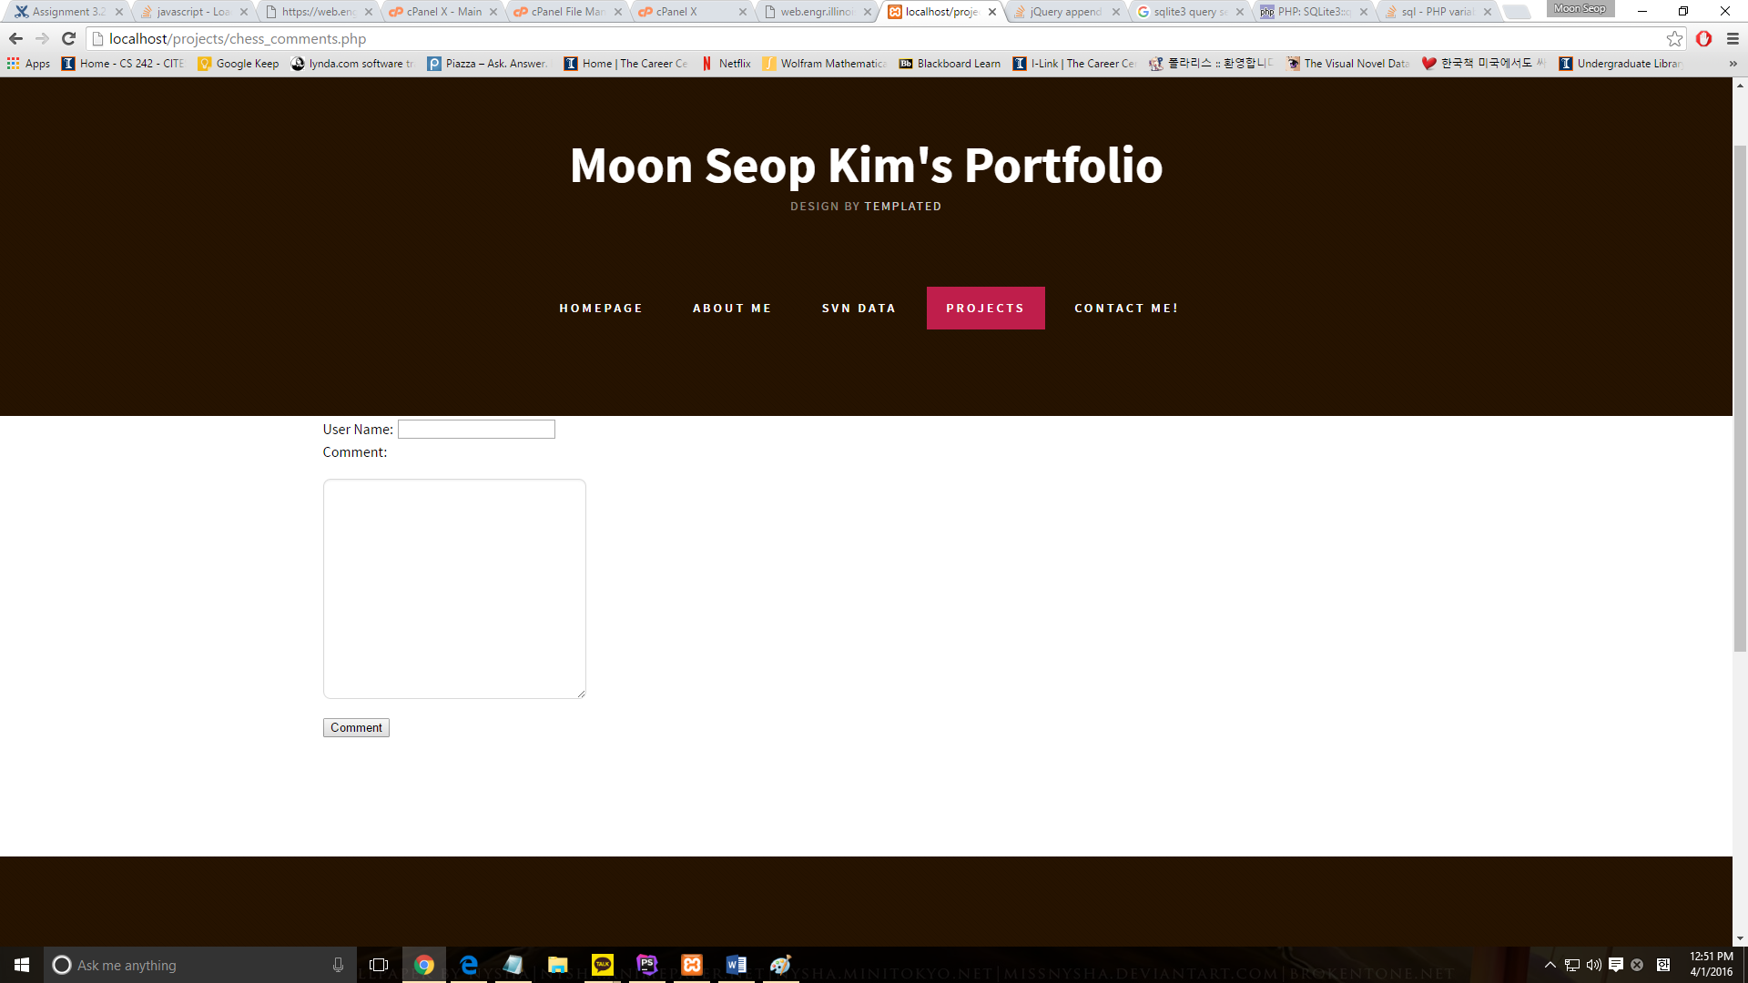

Type in a comment (Ex: name : Moon, Comment: hello)



Check that the comment appears without reloading the page.